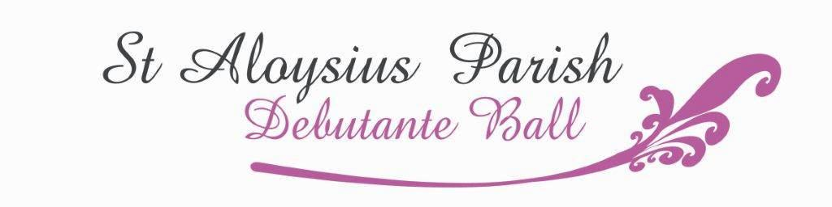
TABLE BOOKING FORM 2021
Form must include all guests names and be returned with payment BY 4TH DANCE LESSON.
Preferred payment method is via direct deposit. Payments by cheque or money order made payable to St Aloysius Parish Debutante Ball. Cash is to be placed in envelope and handed to Ball Coordinator
ACCOUNT NAME: St Aloysius Parish Debutante Ball - BSB: 083 532 - ACCOUNT NO: 2425 67560
Debutante / Partner REFERENCE (Debutante or Partner Surname, Ball Group number)___________________

Bank transfer receipt number ________________________________ (printed copy to be attached to this form)

Date of Ball: _________________
Please circle the table you are booking for-: DEBUTANTE OR PARTNER
(CIRCLE BOTH IF SHARING A TABLE)
DEBUTANTE NAME: ____________________________ PARTNERS NAME: _____________________________
Table booking contact – NAME: _______________________________ PH: __________________________
Please list the debutante or partner first, but do not pay for them as the registration fee includes their meal.
 | GUEST NAME | ADULT $80 | PLEASE TICK IF UNDER 18 | 12 YEARS AND UNDER $45 | LIST ANY DIETARY REQUIREMENTS
1 | DEB OR PARTNER NAME | PAID
2 |  | $ |  | $
3 |  | $ |  | $
4 |  | $ |  | $
5 |  | $ |  | $
6 |  | $ |  | $
7 |  | $ |  | $
8 |  | $ |  | $
9 |  | $ |  | $
10 |  | $ |  | $
TOTAL |  | $ |  | $
If there are guests UNDER 18, please nominate a SUPERVISING ADULT WHO IS OVER 35 YEARS OF AGE.

NAME______________________________________PH____________________________ SIGNED _______________________________
Guests will be admitted on the confirmation of their name on door list that is held at the entrance on night of the ball.
OFFICE USE ONLY-
DATE: REC NO: GUESTS: AMOUNT:
FAMILY PHOTOS
Do you require a Family Photograph: YES / NO (please circle) – FAMILY NAME _____________________________

